Job Application Guidance for Priority Candidates
This document has been created to support Priority Candidates in the process of searching and applying for roles at the University of Oxford.

Internal Jobs Board
- To search for all internal University jobs, visit self-service, which can be accessed through the HR Self-Service page: https://staff.admin.ox.ac.uk/working-at-oxford/you-and-work/hr-self-service
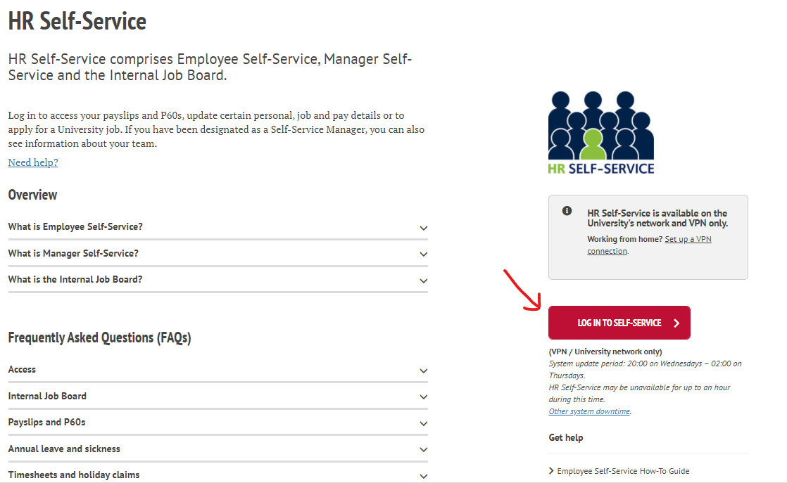

- You will need to log in (make sure you are connected to a VPN).
- On the dashboard, you will see a ‘vacancies’ tab. Here you can see all roles and search by keyword or filter by open and close date.
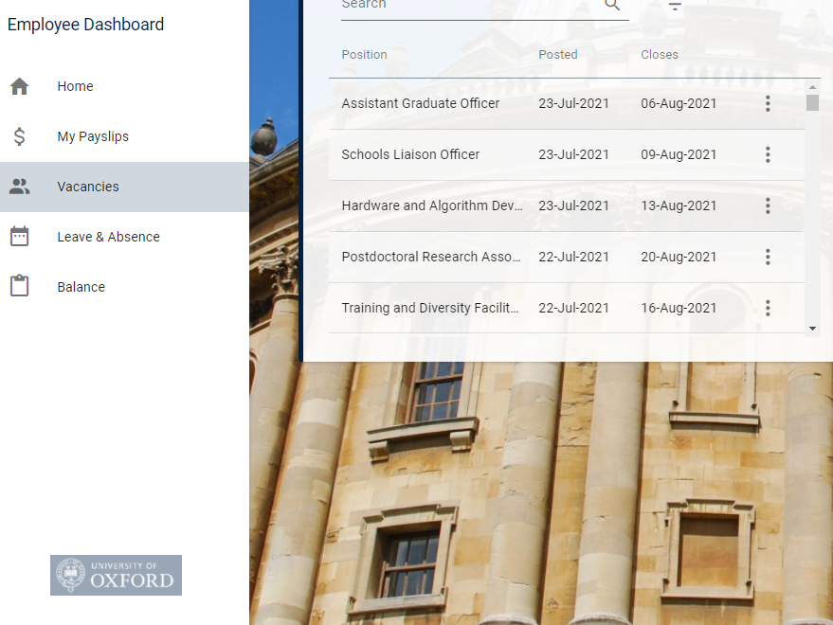

- Select the three dots and ‘View details’ to see more information, including the Job Description. You can apply from this page.
- Remember to attach your priority candidate letter to your application.

See the step-by-step guide on the HR Support pages here: https://staff.admin.ox.ac.uk/internal-job-board-faqs

Externally Listed Vacancies
- To search for all University jobs, visit the vacancies page: https://my.corehr.com/pls/uoxrecruit/erq_search_package.search_form?p_company=10&p_internal_external=E
- Here you can select jobs based on:
- Vacancy ID
- Department
- Vacancy Type (Apprenticeships; Academic; Research; Professional/Management; Support/Technical/Temporary Staffing Service)
- Using keyword search
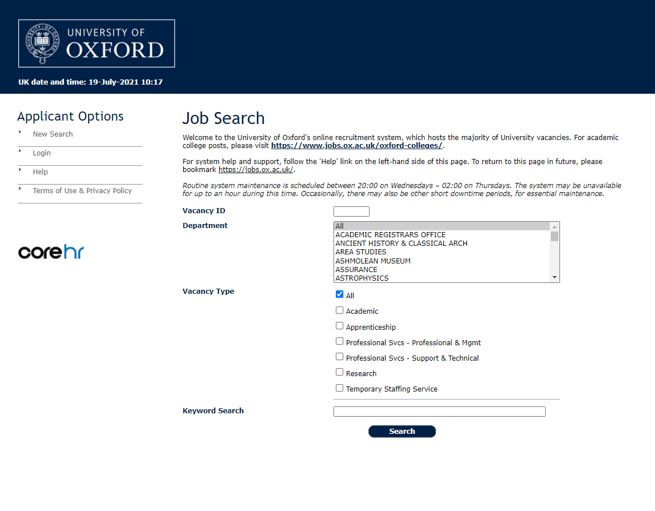
- Once you click ‘search’, all vacancies fitting your search criteria will appear.
- There are vast amounts of jobs posted with different job titles that may be suited to you, so it is worth amending your keyword search to see a wide variety of vacancies.
- Please note that roles are listed in order of soonest closing date, so recently added vacancies may appear later in the search. It is recommended that you check back daily as this often changes.
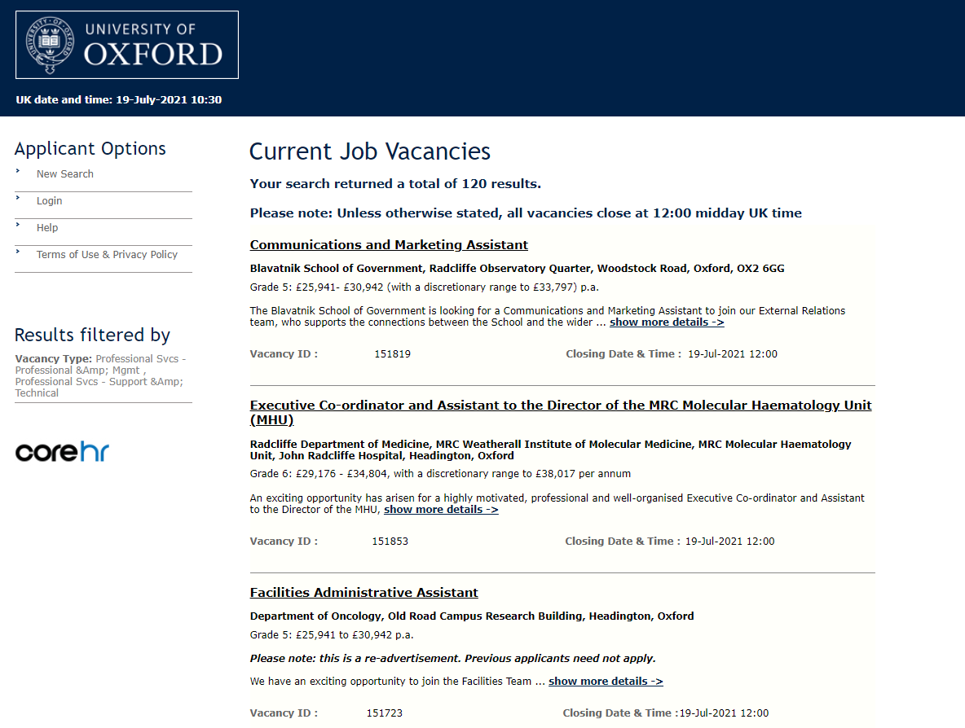
- To find out more about a particular vacancy, click either the title of the role or the ‘show more details’ link.
- From this page, you will be able to download the Job Description and/or apply through the e-recruitment. Remember to attach your priority candidate letter to your application.
Help or further information
For help with technical aspects of your application, please contact: recruitment.support@admin.ox.ac.uk
For queries about the role, please check the contacts given on the job details page (see screenshot below), which may be the hiring manager or an administrator in the department.

